Lab 2: Information Disclosure Vulnerabilities
Objective:
- Information disclosure, also known as information leakage, is when a website unintentionally reveals sensitive information to its users. Depending on the context, websites may leak all kinds of information to a potential attacker, including:
  - Data about other users, such as usernames or financial information
  - Sensitive commercial or business data
  - Technical details about the website and its infrastructure

- The dangers of leaking sensitive user or business data are fairly obvious, but disclosing technical information can sometimes be just as serious. Although some of this information will be of limited use, it can potentially be a starting point for exposing an additional attack surface, which may contain other interesting vulnerabilities. The knowledge that you are able to gather could even provide the missing piece of the puzzle when trying to construct complex, high-severity attacks.
In this lab, students need to:
- Perform two challenges:
  - Source code disclosure via backup files
  - Information disclosure in version control history
- Explain and capture all steps (full windows screen capture).

- Source code disclosure via backup files
- The setup for the “Source code disclosure via backup files” lab on Web Security Academy, using Kali Linux and BurpSuite. It demonstrates the initial step of preparing the testing environment for web security analysis.
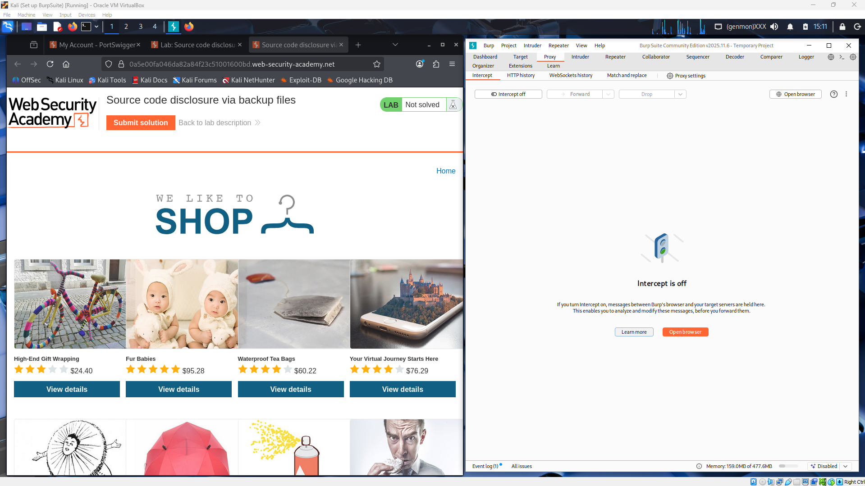
- The robots.txt file of the target website reveals a hidden “/backup” directory. This suggests that the site might store backup or source files there, which could lead to sensitive information exposure or source code disclosure during testing.
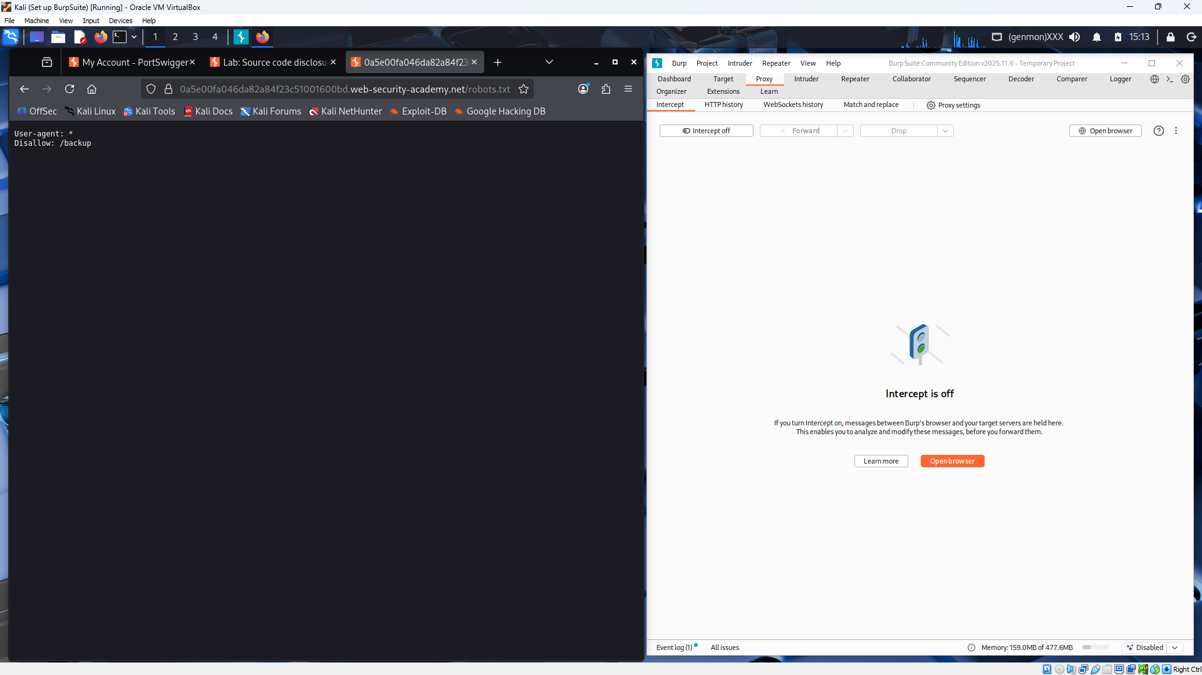
- The target website being analyzed in Burp Suite, with the site map displaying accessible directories, including “/backup.”
- It confirms the connection and response details, helping identify potential points where backup or source files might be leaked.
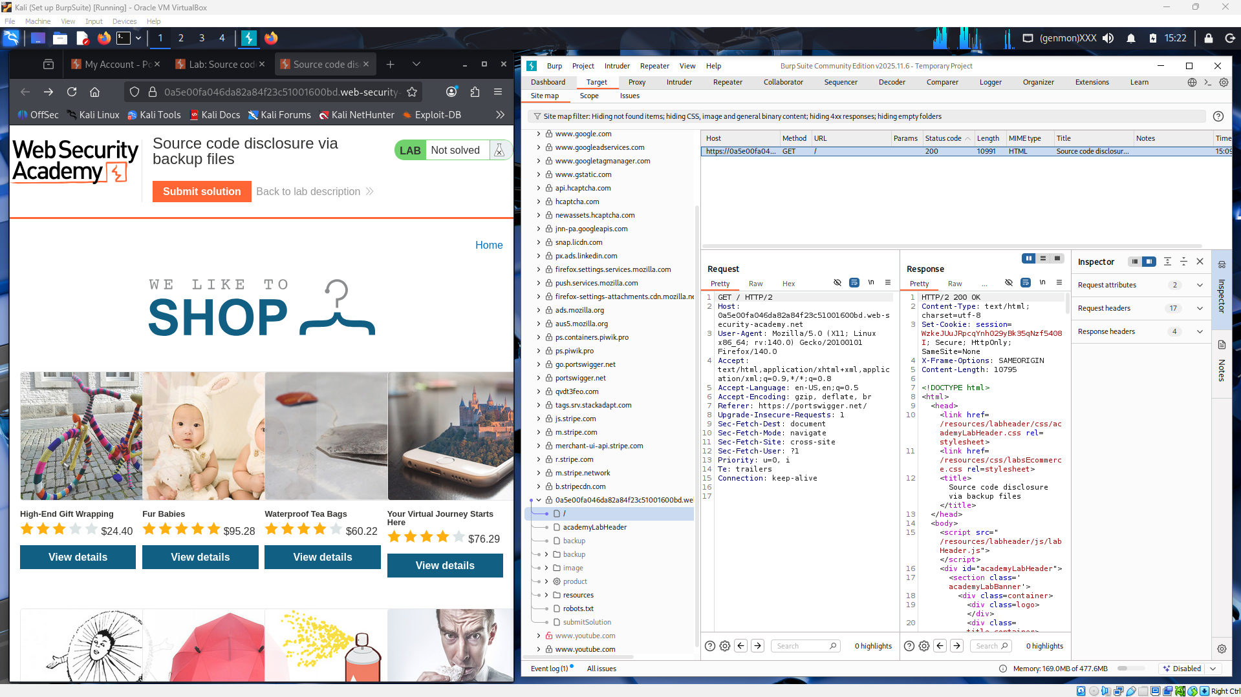
- Using Burp Suite’s Repeater, the request and response were analyzed to confirm source code disclosure via root files, completing the challenge.
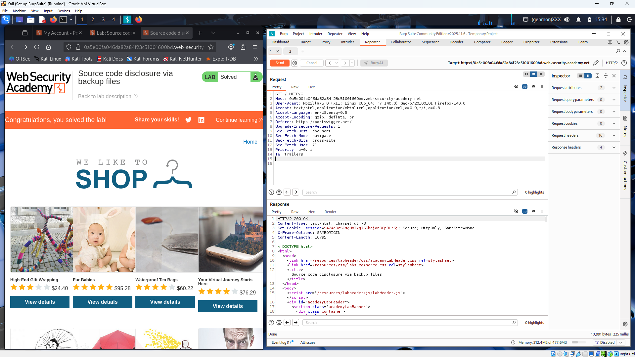
- A GET request to the “/backup/” directory captured in Burp Suite. It verifies access to the hidden folder discovered earlier, a key step in finding exposed backup or source files that could lead to code disclosure.
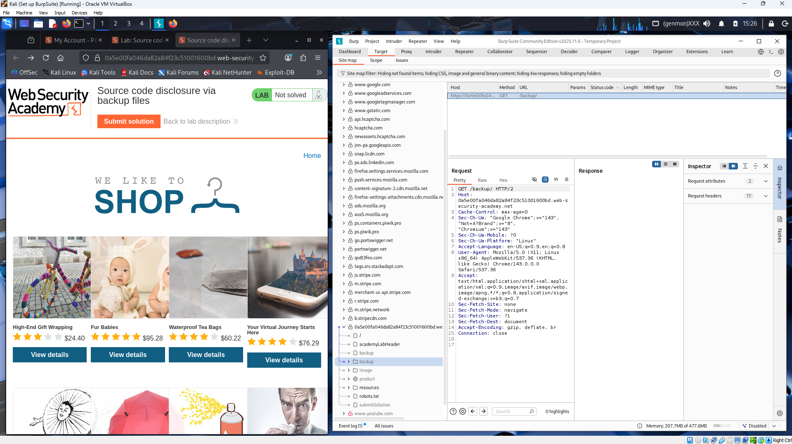
- A GET request to the “/backup/” directory revealing a backup file named ProductTemplate.java.bak in Burp Suite’s response panel. It confirms the discovery of a sensitive backup file that can be downloaded and analyzed to expose the application’s source code.
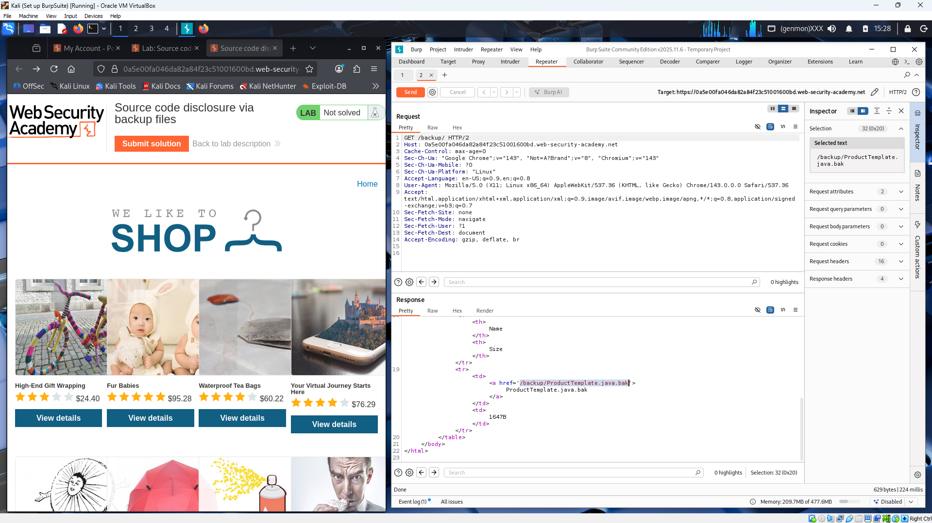
- The retrieval of the ProductTemplate.java.bak file using Burp Suite’s Repeater.
- The response section displays exposed Java source code, confirming a successful source code disclosure through an unprotected backup file.
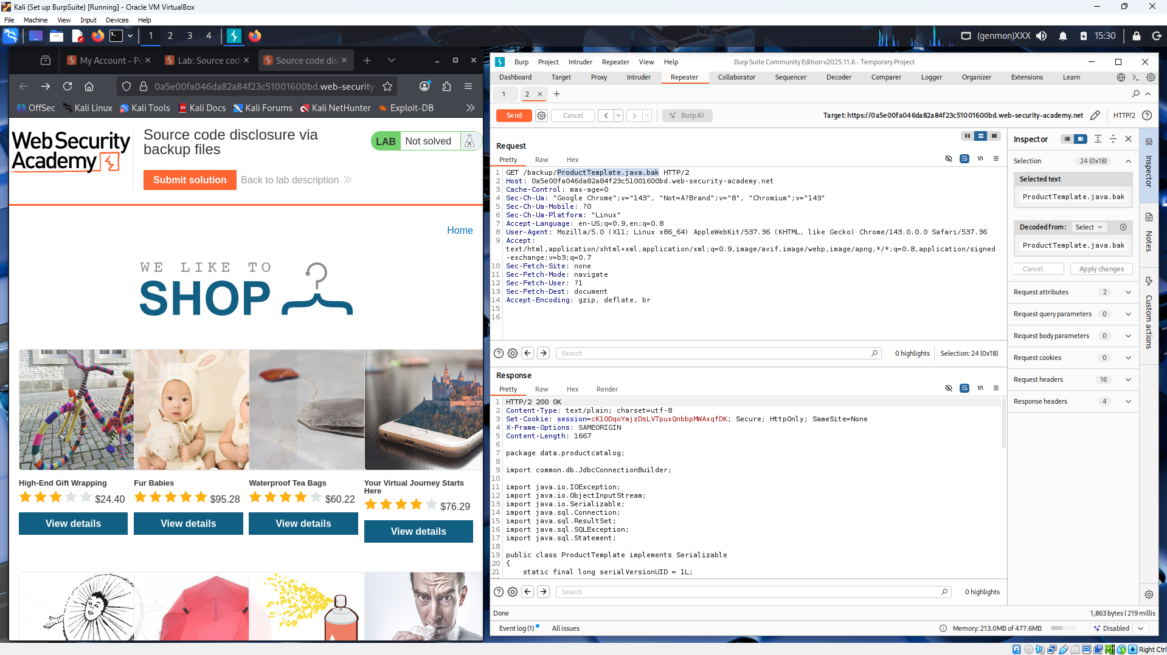
- The extracted source code from the ProductTemplate.java.bak file in Burp Suite, revealing database connection details, including the PostgreSQL password.
- It demonstrates a serious information disclosure vulnerability, as exposed credentials can lead to full database access.
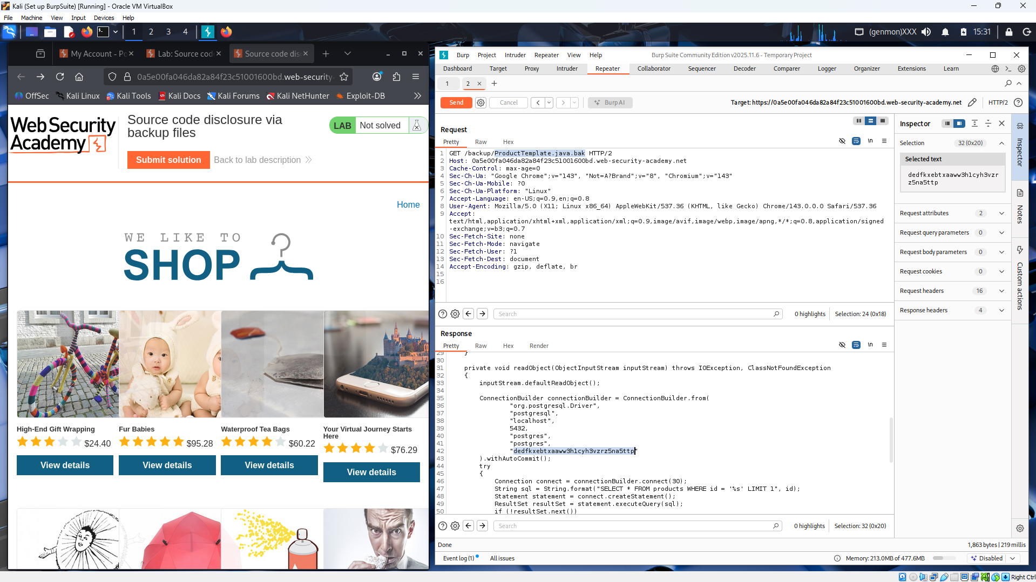

- Information disclosure in version control history
- The “Information disclosure in version control history” lab on Web Security Academy in PortSwigger
- It demonstrates successful exploitation of sensitive data exposure from version control files (e.g., .git), revealing hidden information stored in the project’s commit history.
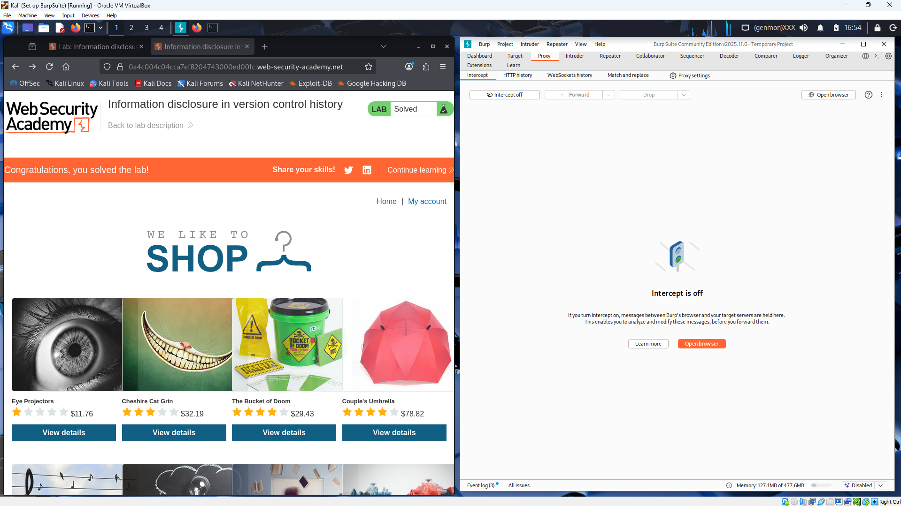
- Burp Suite’s HTTP history captures requests to the target website, including access to the “.git/” directory.
- It confirms that version control data was exposed, allowing retrieval of the Git repository and analysis of commit history to uncover sensitive information.
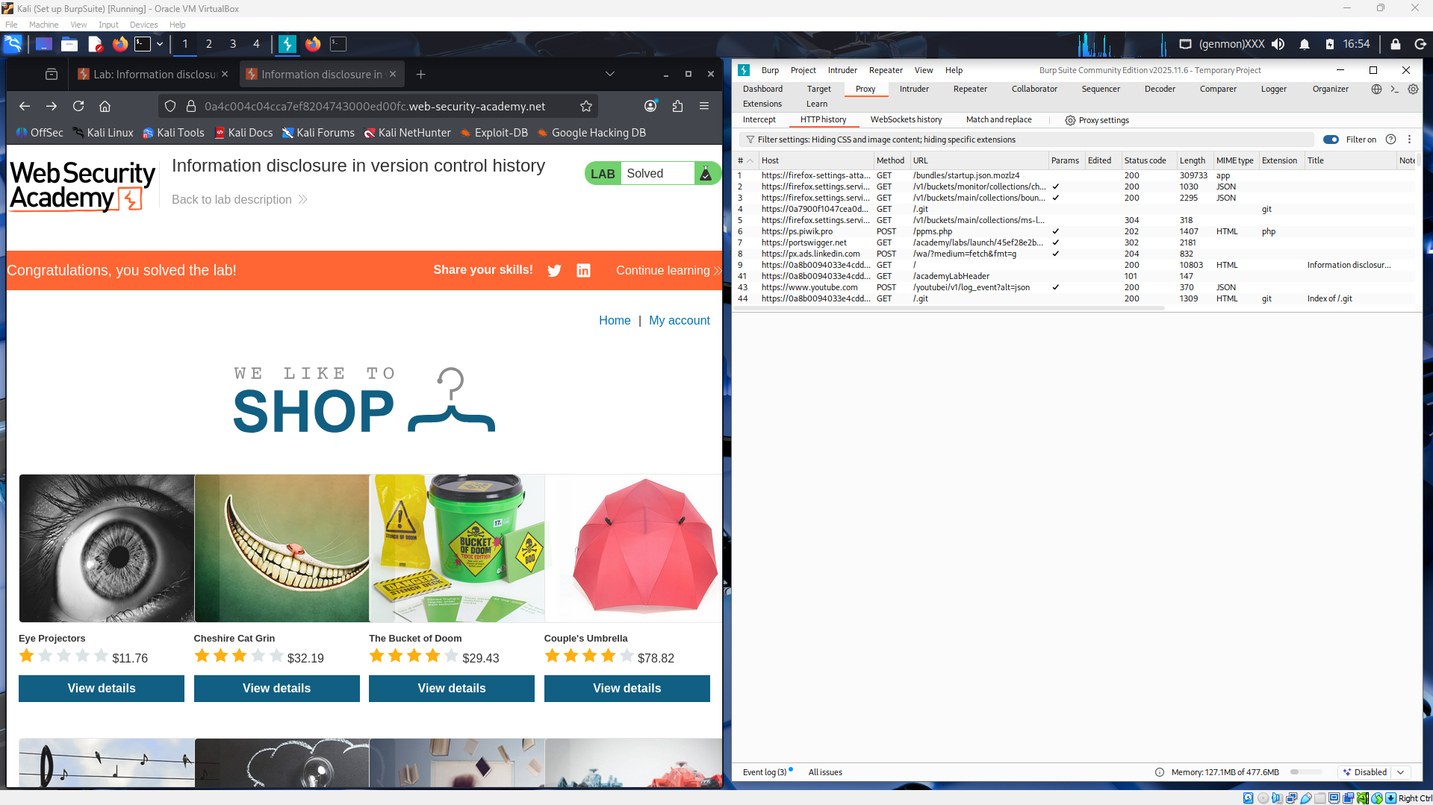
- The “.git” directory listing of the target website, which is publicly accessible.
- It exposes internal version control files such as config, HEAD, and COMMIT_EDITMSG, allowing attackers to reconstruct the source code and reveal sensitive project history.
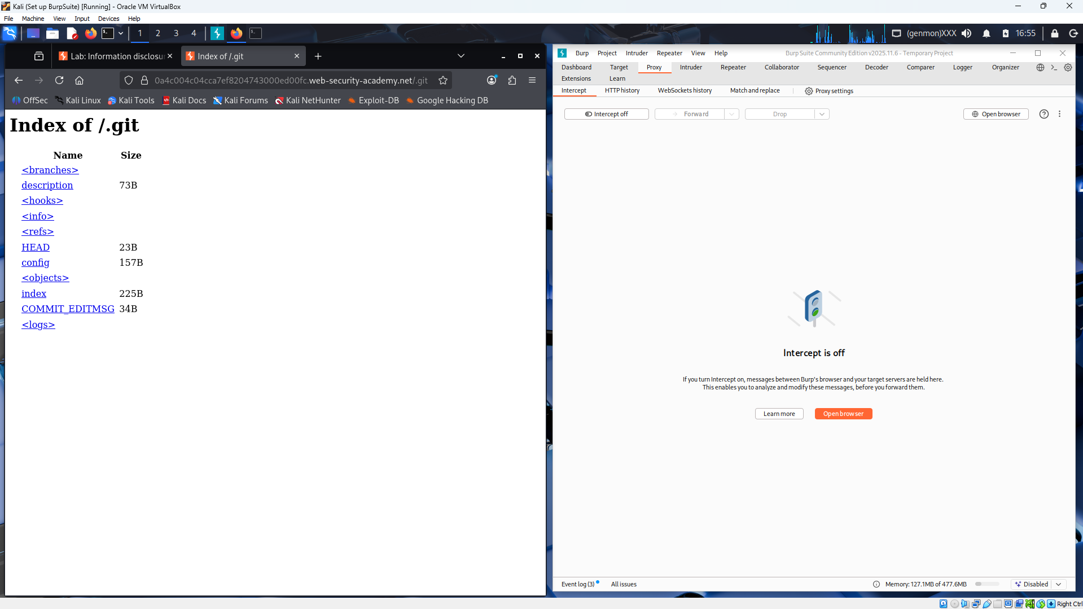
- The use of the wget command in Kali Linux to download the exposed .git directory from the target website.
- It demonstrates how attackers can clone or reconstruct the full repository from the accessible .git folder, leading to information disclosure through version control history.
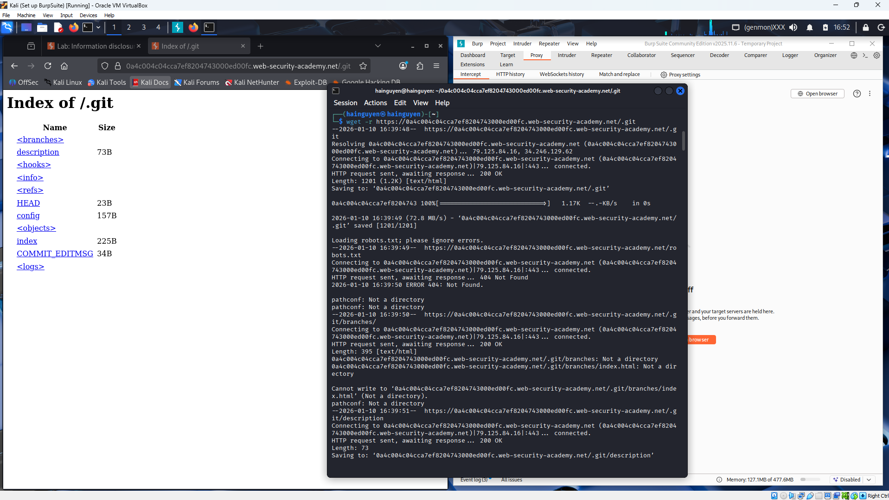
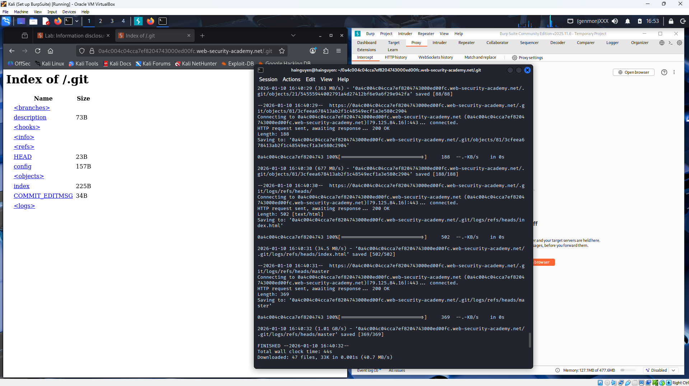

- The downloaded .git repository is being explored in the Kali Linux terminal.
- It confirms that the version control files were successfully retrieved and extracted, allowing analysis of the project’s commit history and potential exposure of sensitive data.
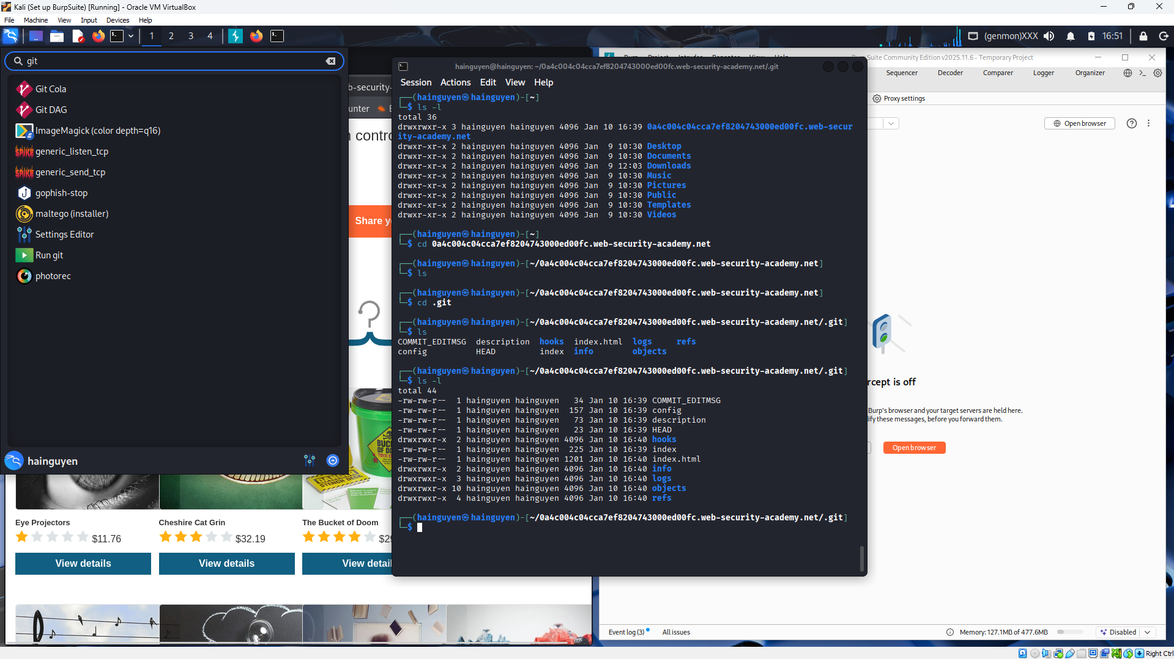
- The Git Cola application is being used to open and inspect the downloaded Git repository.
- It allows reviewing commit history and file changes, confirming that the project’s version control data was exposed and could lead to information leakage.
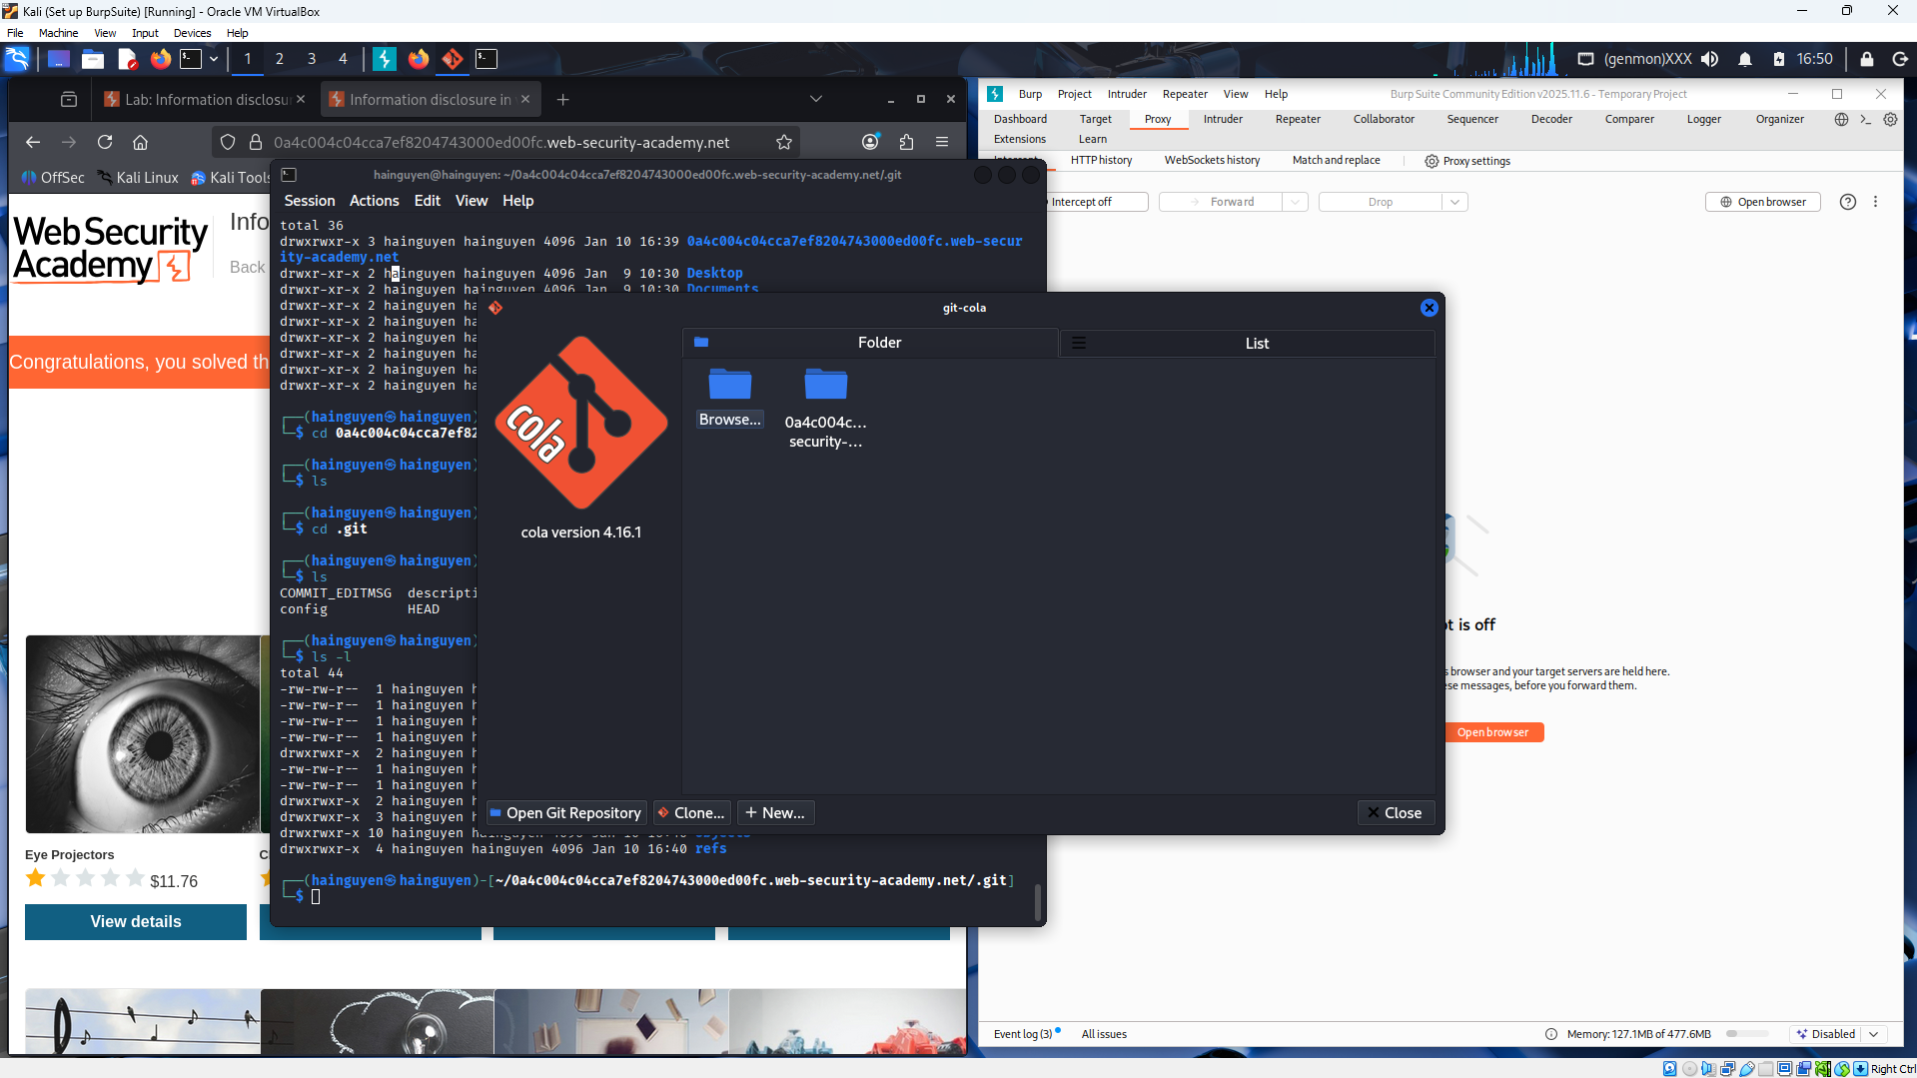
- The Git Cola application interface allows users to open and browse Git repositories. Users can view commit history and file changes, which can lead to the risk of sensitive information exposure if the data is not protected.
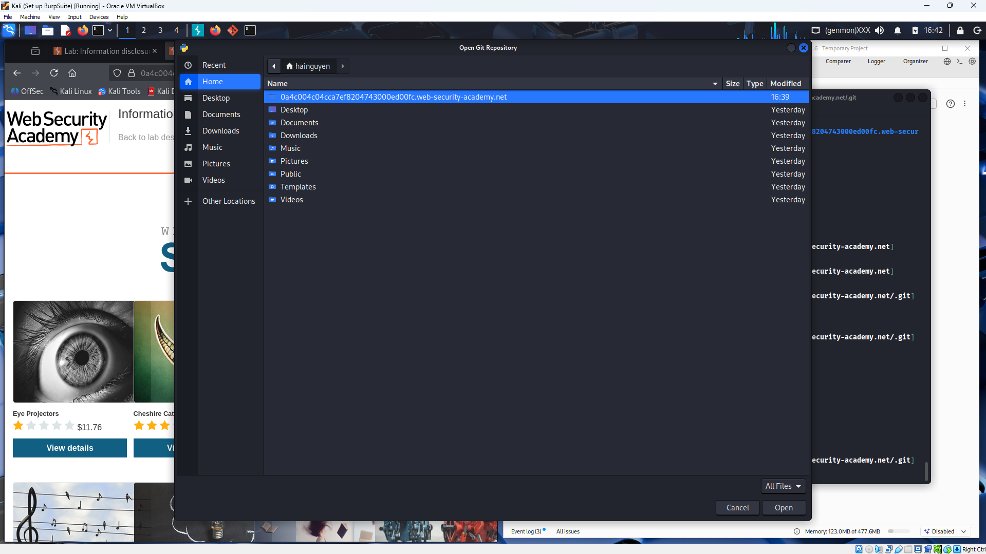
- The Git Cola interface enables users to inspect repository history, including past commits and configuration files. If sensitive data (such as credentials or API keys) was committed and not properly removed, it can still be recovered from version control history, leading to information disclosure risks.
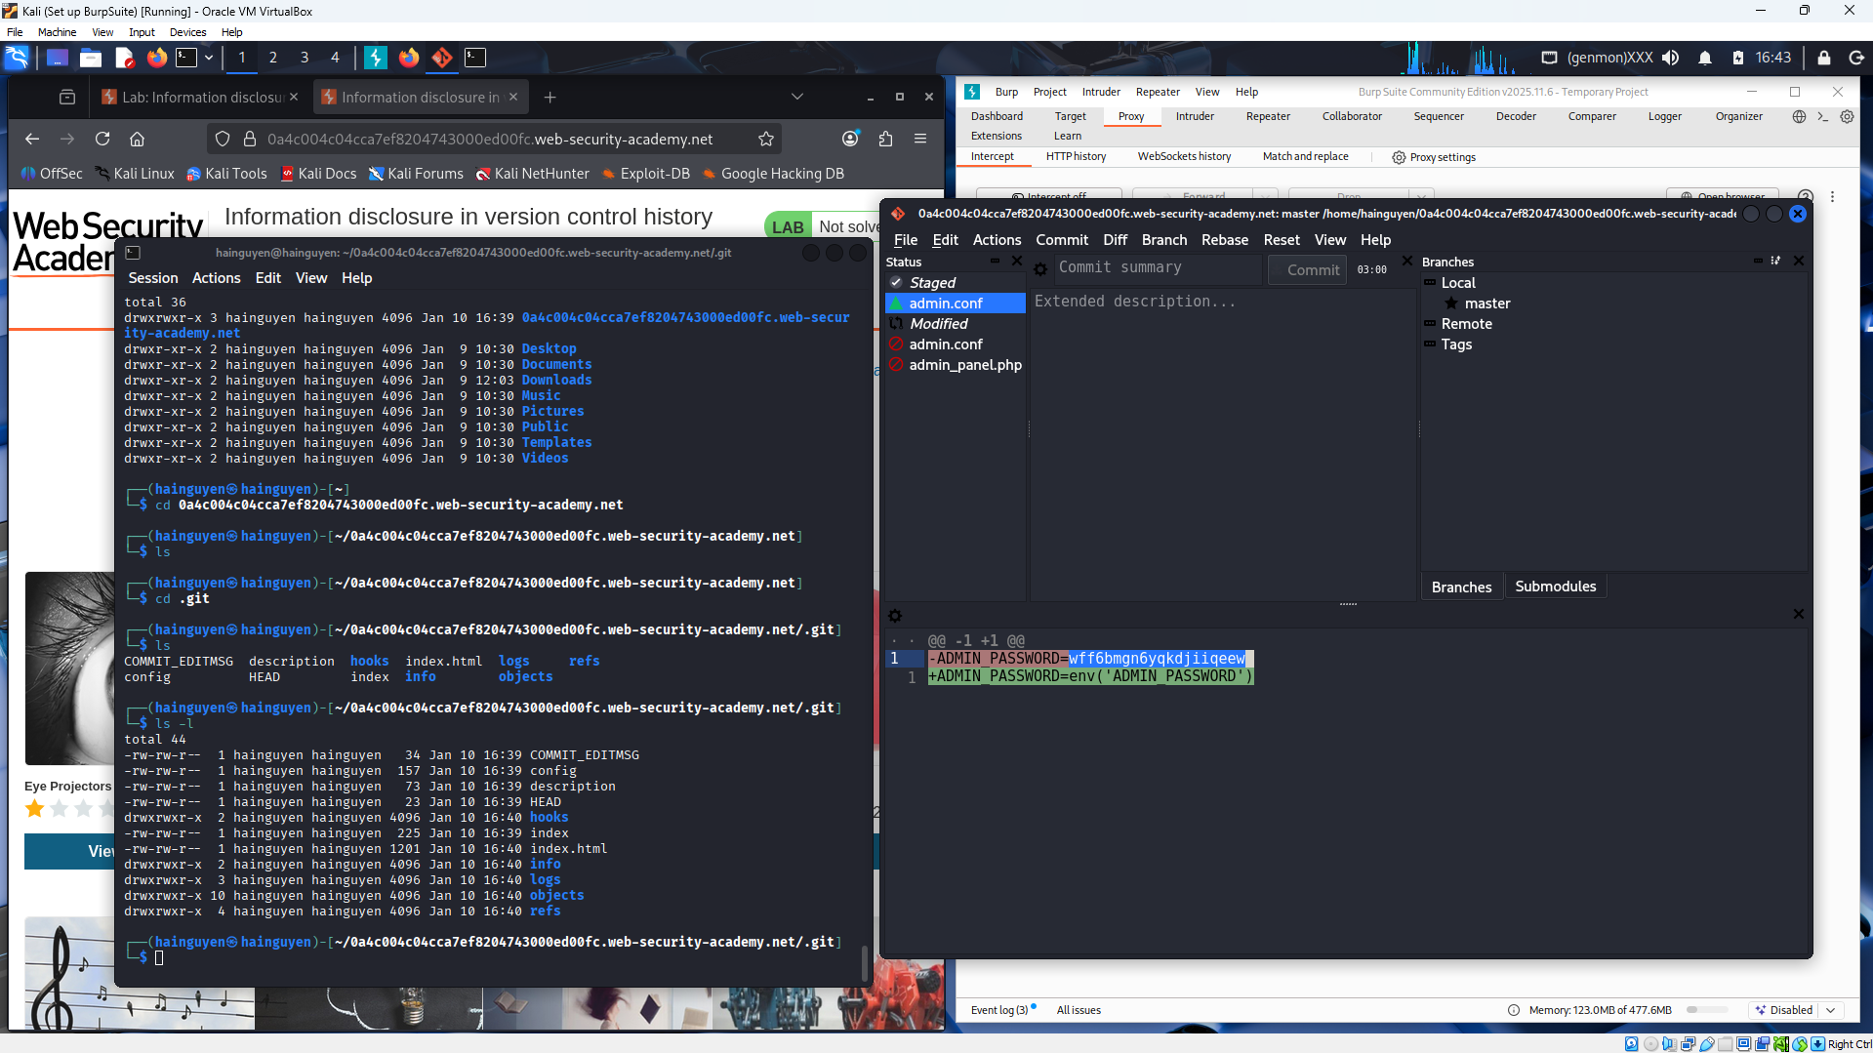
- The image shows that administrator login credentials were exposed through the version control history and then used to access the system. This demonstrates a serious security risk when sensitive data such as passwords or configuration values are committed to Git, enabling unauthorized access to the application.
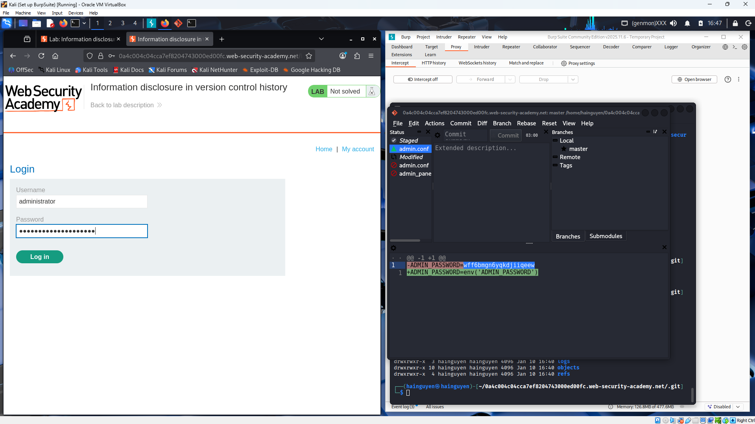
- The screenshot shows successful administrator access after credentials were recovered from the Git version control history. This highlights how exposed secrets in past commits can be exploited to gain full account access, even if the application itself appears secure
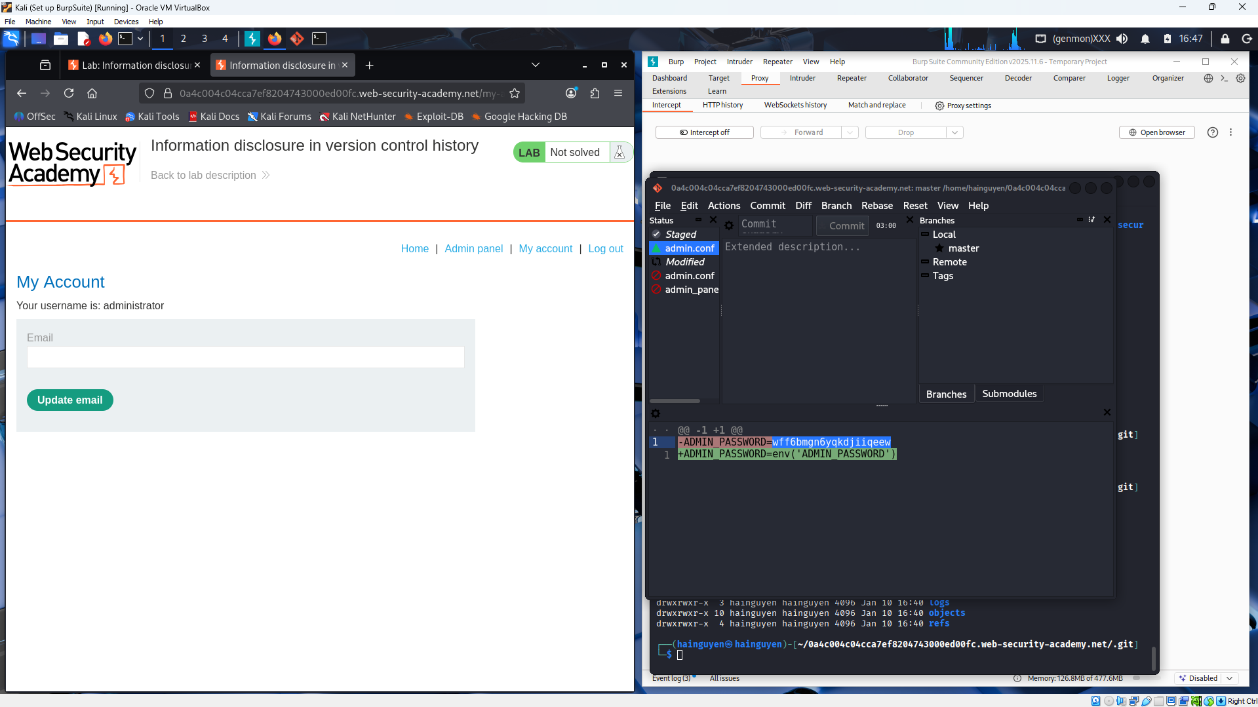
- The screenshot confirms that the lab was successfully completed after exploiting sensitive information exposed in the Git version control history. By retrieving administrator credentials from previous commits, full administrative privileges were obtained, allowing actions such as deleting users and demonstrating the real-world impact of information disclosure in source control systems.
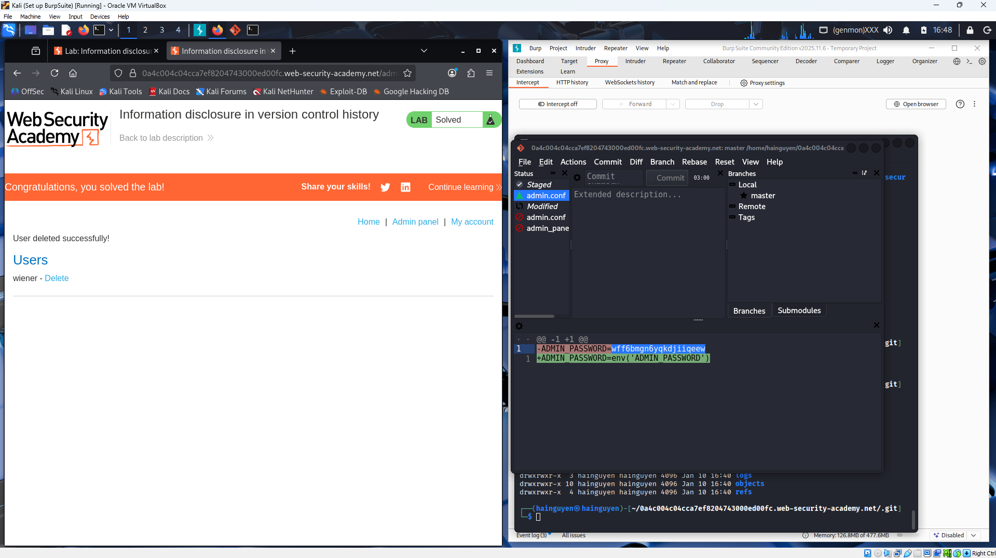
Submit a report addressing all the questions mentioned above in either PDF or Markdown format. Additionally, include a video demonstrating the detailed process of your work to ensure the authenticity of your lab exercise.
The report file name must be Class_YourStudentID _YourName_Lab2

